**Activity: Leaving a Review**

If the location service is active, and the user travels within range of the destination, a notification is sent out to all the participants. If the passengers tap the notification, they’ll be taken to an activity that allows them to leave a rating and a review about the driver.

**Manifest Details**

RateRide.java implements this activity in the Android Manifest. The screenOrientation property is set to “portrait,” while the windowSoftInputMode is set to “adjustPan,” to prevent the layout’s button from moving up with the virtual keyboard.

The Intent filter provides standard access when referenced by name.

**Layout File(s)**

Activity_rate_ride.xml

* This is the only layout for this activity. It contains an imageView to display the driver’s profile picture, a rating bar to leave a score, a text box to write a comment, and two buttons to submit and leave the activity. All of this is contained in a scrollView to support smaller screens.
* ratingBar
  + numStars: 5 -- The size of the rating bar
  + stepSize: 1 -- how quickly the bar should fill up
* submitButton :Button
  + onClick: submitReview – Sends the rating and comment to the server, and sends the user back to the Main Activity
* cancelText: TextView
  + onClick: cancel – exits the activity and brings the user back to the Main Activity

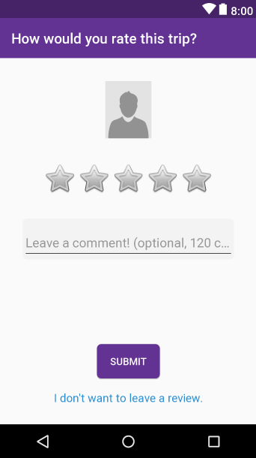

**Class File(s)**

RateRide.java

* RateRide.java implements this Activity. When the application starts, it gets the driver’s profile picture and sets up the rest of the views.
* Variables
  + –queue: RequestQueue – Sends out JSON Requests
  + –prefs: SharedPreferences – Gets the user’s stored access token from the device
  + –value: int – The rating left by the Rating Bar
  + –comment: String – The user’s review in the text box
  + –driverId: String – The driver’s ID number sent by the Location Service. Used to retrieve the profile photo, and to post reviews.
  + –tripId: String –The trip’s ID number sent from the Location Service. Used when sending a review.
* Methods
  + *onCreate(savedInstanceState): void
    - Initializes queue and prefs
    - Pulls the driverId and tripId from the Intent as String Extra
    - Finds the rating bar, and sets its’ onRatingChanged method to initialize “value” with the current rating.
    - Sends a method call to get the driver’s profile photo
  + –getProfilePhoto(): void
    - Sends a JSON Object GET Request to view the driver’s profile picture.
    - When the request responds, ccreate a new instance of DowloadImage task, passing the driver’s ImageView and profilePicture url as parameters.
  + +submitReview(v): void
    - Checks if “value” is greater than 0.
    - Create a variable to hold the TextInputEditText box, and store its value into comment.
    - Create a HashMap of parameters to send in the request, storing the tripId, userId, and comment. If the comment is empty, then “N/A” is stored in its place.
    - Create a new JSON Object POST Request with the parameters. If the request was successful, a Toast message says “thank you” and sends the user back to the Main Activity. If it failed, they are given an error message.
  + +cancel(v): void
    - Returns the user back to the Main Activity without leaving a review.